**Rakan Alshalwi 201902614**

**Bug Life Cycle (Defect Life Cycle)**

When we test software, we often run into bugs. A **bug life cycle** simply describes the journey of a bug from the moment it’s found until it’s either fixed or closed. Think of it like a story: a bug is “born” when discovered, then it passes through different hands until it’s finally resolved.

**Stages in the Life Cycle**

* **New**: A tester or user finds something wrong and reports it. At this point, it’s just sitting in the system waiting for review.
* **Assigned**: The bug gets confirmed and passed to a developer who will take responsibility for it.
* **Open (In Progress)**: The developer starts investigating and working on a solution.
* **Fixed**: A patch or code change is applied. From the developer’s side, the problem should now be solved.
* **Retest / Verified**: The testing team runs the same steps again to check if the fix really works. If it does, the bug is marked verified.
* **Closed**: The issue is done and no more action is needed.
* **Reopened**: If the bug still shows up or the fix doesn’t fully solve it, it’s sent back into the cycle.
* **Rejected / Duplicate / Deferred**: Sometimes a bug is not really a bug, has already been reported, or can wait until later. In those cases, it’s closed with these labels.

**Why It Matters**

This cycle keeps everyone on the same page — testers, developers, and managers all know the exact status of every bug. Without it, some bugs might get lost or ignored.

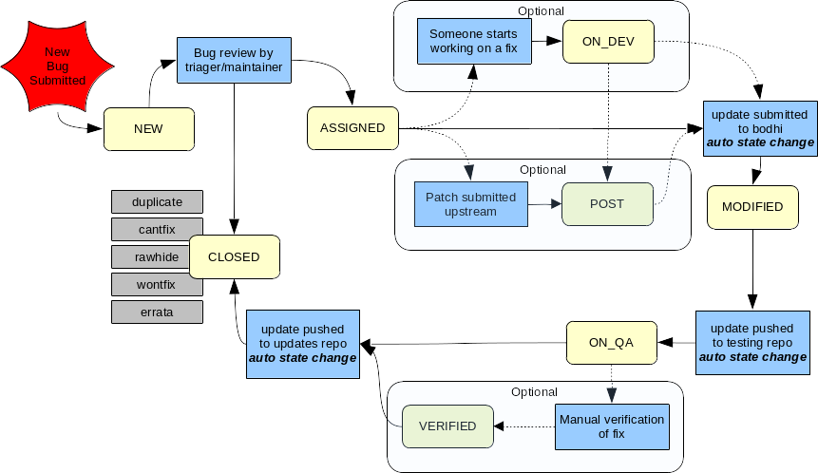

**References:**

* Bugzilla Documentation — Workflow: [4.8. Workflow — Bugzilla 5.2+ documentation](https://bugzilla.readthedocs.io/en/latest/administering/workflow.html)
* BrowserStack Guide — [“Understanding Bug Life Cycle in Testing”](https://www.browserstack.com/guide/bug-life-cycle-in-testing) (Dec 12, 2024)
* Fedora Docs — [“Bug Status Workflow”](https://docs.fedoraproject.org/en-US/package-maintainers/bug_status/) (Jan 13, 2022)